Masses for the Week of November 1st to November 9th, 2025
Saturday | 4:00 p.m.  6:30 p.m. | Intentions of Robert Fetsch and Laura Benke, in thanksgiving for 50th wedding anniv.  Guadalupe Martínez Antonio, 4th anniv., María Fernanda Olivas, 1st anniv. & María del Refugio Olivas.
Sunday | 8:00 a.m. | Jerson Cerna Sánchez & José, Carlos, Lorenzo & Ponciano Sánchez.
Sunday | 10:30 a.m. | Manuela Hernández & Isidro Recio, anniv.
Sunday | 12:30 p.m. | Fermín Del Rosario, Antonio Reyes y Magdalena López Ramos.
Monday
Tuesday | 6:30 p.m. | Calvin Williams, b’day & Pedro Martinez, b’day rem.
Wednesday | 6:30 p.m. | Ramon Castillo & B’day int. for Angel Acevedo.
Thursday | 6:30 p.m. | Mass available.
Friday
Next Saturday | 4:00 p.m.  6:30 p.m. | Refugio & Lilia Pedraza & Benancio & Prisciliana Rodriguez.  Omar Bencomo & health of Raul Bencomo.
Next Sunday | 8:00 a.m. | Alfredo Lozano & María Victoria Ibarra.
Next Sunday | 10:30 a.m. | Isidro González Ramírez, Diego Sarabia & intentions of Holy Family Parishioners.
Next Sunday | 12:30 p.m. | Viviana Medrano, 4th anniv., Miguel Domínguez, 3rd anniv. Y int. Ministerio de Prev y Rescate.
Saturday – November 1st  Confessions: 3:00 p.m. & 5:15 p.m.  English Mass: 4:00 p.m. & Spanish Mass: 6:30 p.m.  Sunday – November 2nd  Mass: 8:00 a.m. & 12:30 p.m. in Spanish and Bilingual Mass: 10:30 a.m. |  |  | Collection – October 25th & 26th, 2025  Sunday Collection 4,084.86  Children’s Mass 222.00  Marriage Books 40.00  CCD Retreat Fees 20.00  Candles 206.00  CCD Bibles 120.00  Altar Flower Donations 148.00  Guadalupe Mass Fundraiser 2,616.00  Mass Offering 10.00  Total deposit: 7,466.86  Project Fund Donation: $ 300.00  * * * * * * * * * * * * * *  All Souls Day and Saints Day – This year All Saints Day falls on Saturday, November 1st. While it is not a Holy Day of Obligation, it remains a Solemnity. All Saints Day Mass was offered on Friday, October 31st. On November 2nd All Souls Day, since it falls on a Sunday, we will have our regular services. We will have All Souls envelopes available for you to place your donation and also write the names of your departed. The envelopes will remain on the altar for the month of November to be remembered during the month.  Attention Lectors- Part 1 –Training for new lectors will be on Friday, November 7th from 6 p.m. to 8 p.m. (inside church) Part 2 will be on Friday, November 14th from 6 p.m. to 8:00 p.m. (Inside Church). This is for all ages, in both English and Spanish and you must register with Crystal by calling or texting name to (970) 690-6415.

Monday –November 3rd

No services.

Tuesday – November 4th

Confessions – 5:30 p.m. to 6:15 p.m.

Rosary: 6:00 p.m.

Spanish Mass: 6:30 p.m.

CCD Classes: 6:00 p.m.

Adoration following 6:30 p.m. Mass to 10:00 p.m.

Wednesday – November 5th

Confessions – 5:30 p.m. to 6:15 p.m.

Rosary: 6:00 p.m.

Spanish Mass: 6:30 p.m.

CCD Classes: 6:00 p.m.

Thursday – November 6th

Confessions – 5:30 p.m. to 6:15 p.m.

Rosary: 6:00 p.m.

Spanish Mass: 6:30 p.m.

CCD Classes: 6:00 p.m.

Friday – November 7th

New Lector Training: 6:00 p.m. – This will be in the church.
Saturday – November 8th  Confessions: 3:00 p.m. & 5:15 p.m.  English Mass: 4:00 p.m. & Spanish Mass: 6:30 p.m.  Sunday – November 9th  Mass: 8:00 a.m. & 12:30 p.m. in Spanish and Bilingual Mass: 10:30 a.m. |  |  | We have Adoration every Tuesday after the 6:30 p.m. Mass. Every 1st Tuesday of the month Fr. Jean-Marie gives Reflection from 7:30 p.m. to 8:30 p.m., from 8:30 p.m. to 9:00 p.m. will have meditation time and at 9:00 p.m. the Rosary is recited. 2nd, 3rd & 4th Tuesday will be the same but offered by lay ministers.  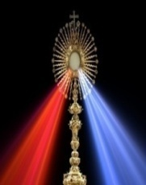
We invite you to come and pray the rosary before weekday masses on Tuesday, Wednesday & Thursday at 6:00 p.m.  Healing Mass – Misa de Sanación – Our next healing mass will be on Friday, November 28th at 6:30 p.m.  Mark your calendar for our next Youth Mass on Sunday; November 16 at 6:30 p.m. This is a great opportunity to connect with other youth from our community.  Spanish Mass and Confessions started again on September 20th. This evening Mass is only offered during our religious education school year. Confession time is from 5:15 p.m. to 6:15 p.m. and Spanish Mass at 6:30 p.m.  Adult Faith Formation  Come join us in a six week Biblical study  to prepare our hearts for the  Holy season of Advent  Tuesday evenings 6:30 - 8:00 pm  Meredith Hall west side Church entrance  Contact: Christy - (970) 568-6372  This is to inform you that on All Souls Day, all donations received for Mass donation only will be given to the celebrating priest. We ask that you please use envelope marked All Souls Day Mass int. Se les informa que las ofrendas que se reciba para las misas y intenciones de difuntos será dado al sacerdote que oficie la misa y pedimos que utilicen el sobro que diga All Souls Day/ Fieles Difuntos.  WEDDING BANN : 2nd announcement  This is to announce the upcoming wedding of Alberto Perez Lenz to Karina Gomez Lenz in parish of Our Lady of the Rosary in Emiliano Zapata, Tabasco Mexico on January 3, 2026. Any person having an impediment of this marriage please contact Fr. Jean-Marie Mwenze.  AMONESTACIONES : Segundo Anuncio  Se anuncia la boda de Alberto Pérez Lenz y Karina Gómez Lenz en la parroquia de Nuestra Señora del Rosario en Emiliano Zapata, Tabasco, México, el 3 de enero de 2026. Si tiene algún razón para el impedimento de contraer matrimonio, por favor, contacte al Padre Jean-Marie Mwenze. |  |  |  | Atención, lectores: Parte 1: La capacitación para nuevos lectores será el viernes 7 de noviembre de 6:00 pm a 8:00 pm (dentro de la iglesia). Parte 2 será el día viernes, 14 de noviembre de 6:00 pm a 8:00 pm (dentro de la iglesia). Es para todas las edades, tanto en inglés como en español. Debe registrarse con Crystal llamando o enviando un mensaje de texto con su nombre al (970) 690-6415.  Nuestra próxima misa de sanación será el día viernes, 28 de Noviembre a las 6:30 p.m. Todos están invitados a participar.  Jóvenes, los invitamos a nuestra próxima misa para los jóvenes el día 16 de Noviembre a las 6:30 p.m. Esta misa es ofrecida una vez por mes durante el año escolar del catecismo.  Los invitamos a rezar el rosario los días martes, miércoles y jueves a las 6:00 p.m. antes de la misa de las 6:30 p.m.  Tenemos Adoración todos los martes después de la Misa de las 6:30 p.m. Cada 1er martes de mes, el P. Jean-Marie da una Reflexión de 7:30 p.m. a 8:30 p.m., de 8:30 p.m. a 9:00 p.m. es tiempo de meditación y a las 9:00 p.m. se rezará el Rosario. El 2º, 3º y 4º martes serán los mismos, pero ofrecidos por ministros laicos. Los invitamos a participar!  El Centro Marisol es un centro que apoya con asistencia básica a familias por todo Colorado (nacimiento a edad de 5) Apoyan con panales, formula, ropa de niños y más. Para más información marque (970) 581-8803.  Atención Conductores ¡ – les hacemos este aviso para pedir su cooperación para evita un accidente. Les vamos a pedir que el tráfico en la salida de la iglesia sea solamente a un lado y que no entren por el lado de la calle de Cherry Street. También les hacemos el recordatorio que no estaciones autos que no caben en el estacionamiento porque no pueden pasar los autos ya que algunos carros se han dañados porque no hay espacio suficiente. Attention Drivers- in order to avoid auto collisions, we are asking that you please only travel in one direction while leaving the church. Please do not enter from cherry street into parking lot. Also we ask that autos that are too long, not to park in smaller parking area because it makes it hard for autos to maneuver thru parking lot and we have had some autos damaged. We ask for everyone’s cooperation. Thank you!

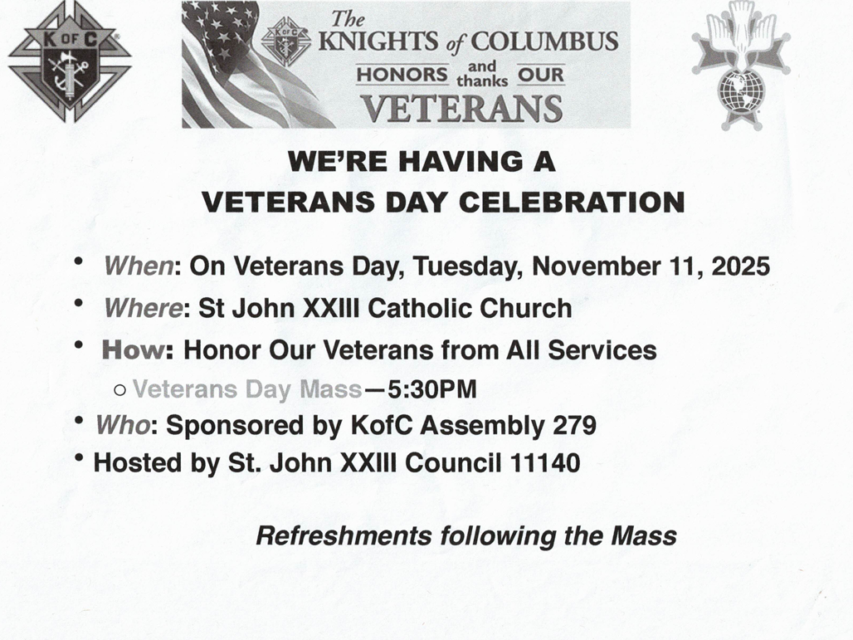
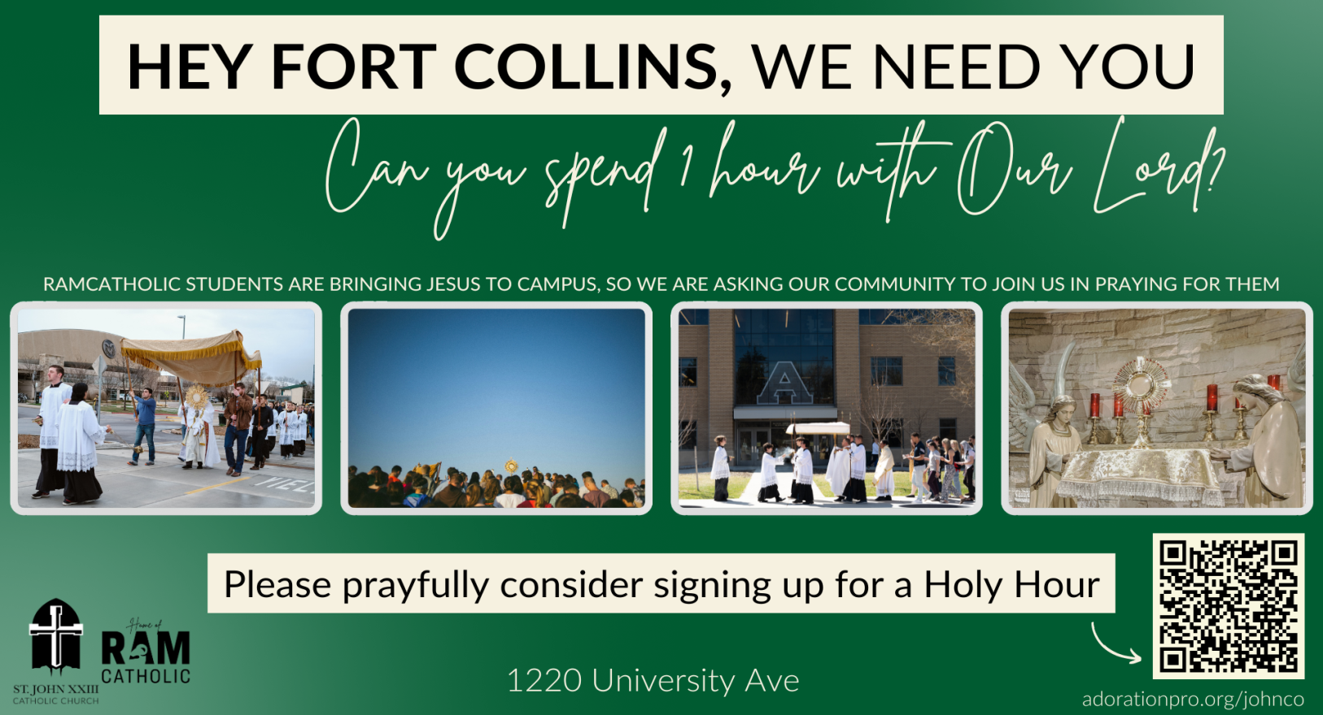

Holy Family November 1st to November 9th, 2025
Catholic Church
326 N. Whitcomb Street, Fort Collins, CO 80521 Office Number : (970) 482-6599
Email: holyfamily.ftcollins@comcast.net Fax Number : (970) 482-8045

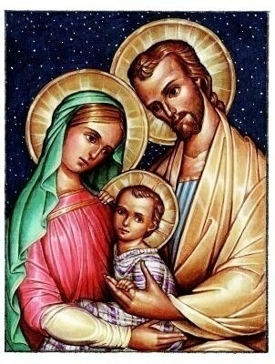
Office Hours: Closed Monday Open: Tuesday, Wednesday & Thursday; 10:00 a.m. to 7:00 p.m. Friday; 10:00 a.m. to 1:00 p.m.
Parish Administrator -
Rev. Simon Kalonga (970) 482-4148
email: frsimon@stjosephfc.org

Parochial Vicar:
Rev. Jean-Marie Mwenze (970) 999-5322
email: jmiyamba@yahoo.com

Secretary
Maria R. Fuerte
Emergency / Emergencia (970) 308-8444

CCD Office / Oficina del Catecismo
Haydee Lara
Office number / Oficina (970) 657-2905

Marriage Prep & 15 Celebrations
Preparación de Quinceañera y Bodas
Call Parish Office - Llamar a la oficina parroquial.

Prevention & Rescue Group / Prevención y Rescate
Dagoberto Torres

Family Movement Group / Movimiento Familiar
Alma Cornejo

Baptism / Bautismo
Baptisms are monthly and are held the last Saturday Mass Schedule / Horario de Misas
of each month at 10:00 a.m. Tuesday, Wednesday & Thursday: 6:30 p.m.
Baptism classes are held the last Sunday of the month in (Spanish)
at 9:30 a.m. No Pre-registration is required Saturday: 4:00 p.m. (English) 6:30 p.m. (Spanish)
Bautismos son los últimos Sábados de cada mes a las Sunday: 8:00 a.m. & 12:30 p.m. (Spanish Masses)
10:00 a.m. Clases para el bautismo son los últimos & 10:30 a.m. (Bilingual Mass)
domingos de cada mes a las 9:30 a.m.

Confession / Confesiones
Tuesday, Wednesday and Thursday: 5:30 p.m. to 6:15 p.m.
Saturday: 3:00 p.m. to 3:45 p.m. & 5:15 p.m. to 6:15 p.m.

